Propel-i
Application Design and
Object Model

Version: 0.2

March 9, 2019

Change Log 2
1 Introduction 3
2 Project initialization / creation 4
2.1 Software development tools - Spring Boot 4
2.1.1 Bootstrapping 4
3 Project structure 6
3.1 Common service parent project 6
3.2 Main Micro-services project 6
3.2.1 Bootstrapping 6
3.2.2 Maven 6
3.2.3 Configuration 6
3.3 Utility projects 7
3.3.1 Kafka-messaging-util 7
3.3.2 Redis-cache-util 7
3.3.3 Common-util 7
3.3.4 Camunda-bpm-util 7
3.3.5 Security-util 7
3.3.6 Session-mgmt-util 7
4 Project packages 8
5 Error handling 9
5.1 Exception Handling 9
5.2 Response structure 9
5.3 Circuit Breaker 9
6 Design Principle 10
6.1 Command Query Responsibility Segregation 10
6.2 API Gateway or Backend for Front-End 10
7 Caching 11
7.1 Session Handling 11
7.2 Master Data Caching 11
8 Logging 12
9 API Visioning 14
10 Integration 15
10.1 Database- Spring data jpa 15
10.2 Rest – Spring REST Template 15
10.3 Messaging – Spring Kafka 16
10.4 Caching- Spring data redis 16
10.5 BPM - Camunda 16
11 Services mesh (Registry, Discovery and Load balancing) 17
12 Deployment 18
12.1 Dockerization of Micro Services project 18
12.2 Registry of image 18
12.3 Kubernetes cluster 18
13 Authentication 19
14 Authorization 20
14.1 Application Authorization 20
14.2 API Authorization 20
15 Coding Standards 21
15.1 Naming conventions 21
15.2 Programming Standards 21
16 Testing 22
17 High Level flow 23
17.1 Sequence diagram 23
Change Log
Change Date &  Version | Requester | Editor | Change Description
18-March-2019 |  | Hafeez M Khan | 0.1
17-April-2019 |  | Arun Singh | 0.2

Introduction

The purpose of this document is to lay down the guidelines that needs to be followed for every Microservices project to be created in implemented Propel-I system.

Project initialization / creation

Software development tools - Spring Boot

Bootstrapping
Spring Initializer - Bootstrapping a Spring Boot application by using Spring Initializer.
- Spring Initializer www.start.spring.io and choose Build, Spring Boot Version and platform. Also, Provide a Group, Artifact and required dependencies to run the application.
- Select Maven project and dependencies (Web ,Jdbc, postgress,....) and generate project.
- Save project and extract it.
- Now import this project by using import option from the STS (Spring Tool Suite) IDE.
OR
New Maven Starter Project with Dependencies
- Web
- Jdbc
- Postgress
- .............

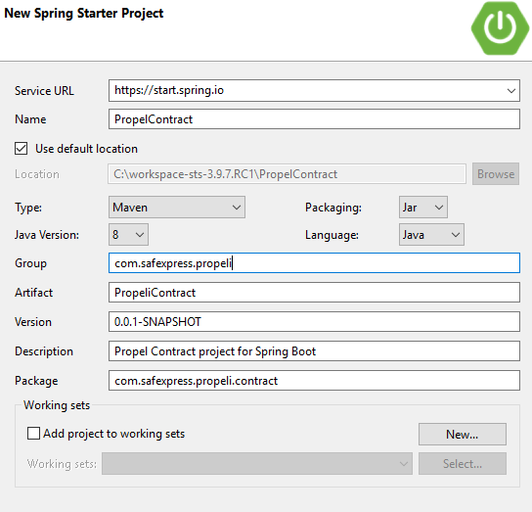
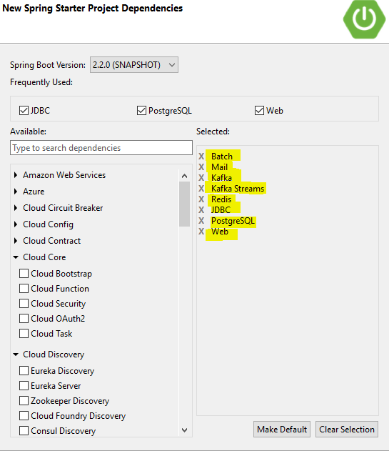

Project structure

Common service parent project
Common service parent project contains all common dependencies (jar, plugins etc.). All microservices and utility projects with inherit this project pom. All dependencies versions will be controlled from here. Dependencies which are specific to microservice or utility project should be present in their respective project.

Below is common service parent pom.


Below is sample microservice pom that use this common service parent pom.



Main Micro-services project

Bootstrapping
Spring Initializr OR New Starter Project with Dependencies.

Maven
Maven will be used as a build tool.

Configuration

application.yml
All configuration related to database, redis logging, kafka goes into application.yml file. For every property corresponding value is fetched from environment variable(If present) else a default value is assigned. There will be a separate property file for dev, test, prod environment. Configuration loading is controlled through spring profile.Below is a sample application.yml file.


logback.xml
All configuration related to logging should be mentioned in logback.xml file.


Utility projects
Utility Project shall be simple Maven project. Jar file can be shared (dependency created ) by other projects.
There will be separate utility projects for Kafka integration, Redis cache integration, Camunda BPM integration, Authentication & authorization integration, Session management etc.

Kafka-messaging-util
Kafka-messaging-util is a common utility project responsible for connecting to kafka cluster. If a microservice need to connect to kafka cluster, below dependency needs to be included in pom.

<dependency>
<groupId>com.safexpress.propeli</groupId>
<artifactId>kafka-messaging-util</artifactId>
</dependency>

Redis-cache-util
Redis-cache-util is common utility project responsible for distributed caching across microservices. If a microservice need to use redis caching in the application, below dependency needs to be included in pom.

<dependency>
<groupId>com.safexpress.propeli</groupId>
<artifactId>redis-cache-util</artifactId>
</dependency>

Common-util
Common-util is common utility that contains all common features like eexceptions, dtos etc. If a microservice needs to use this utility jar, below dependency needs to be included in pom.

<dependency>
<groupId>com.safexpress.propeli</groupId>
<artifactId>common -util</artifactId>
</dependency>

Camunda-bpm-util
TBD

Security-util
TBD

Session-mgmt-util
TBD

Project packages
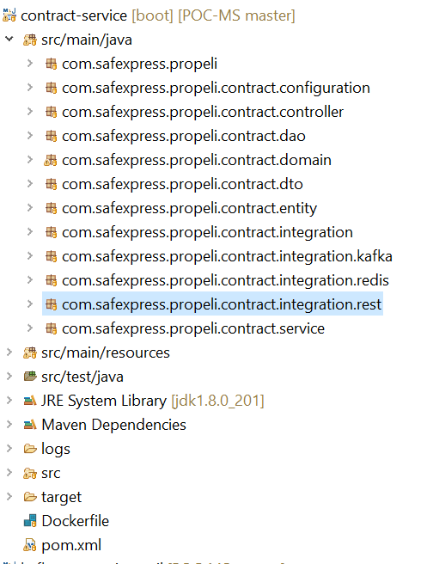

Error handling

Exception Handling

Using Controller Advice

Response structure

{
"message": <Service response message>,
"data": {
},
"success": [true / false],
"respCode": "<Service response code>"
}

Circuit Breaker
Exception Handling in case of Inter service communication

To prevent a network or service failure from cascading to other services.
A service client should invoke a remote service via a proxy that functions in a similar fashion to an electrical circuit breaker

Design Principle

Command Query Responsibility Segregation
- Building and deploying microservices with event sourcing, CQRS and Docker. Event sourcing (ES) and command query responsibility segregation (CQRS). Applications consist of loosely coupled components that communicate using events.
- Inter-service communication mechanism and deal with partial failure
- Implementing requests that span multiple services
- Implementing queries that need to retrieve data owned by multiple services.
- The API Composition and Command Query Responsibility Segregation (CQRS) patterns.

API Gateway or Backend for Front-End
How do the clients of a Microservices-based application access the individual services?
- A client needing the details to fetch data from numerous services.
- Different clients need different data
- HTML5/JavaScript-based UI for desktop and mobile browsers - HTML is generated by a server-side web application
Backend for front-end
- It defines a separate Front Controller (API gateway ) for each kind of client. If there are three kinds of clients: web application, mobile application, and external 3rd party application.
- There are three different Front Controller(API gateways). Each one is provides an API for its client.
- Reduces the number of requests/ round-trips. For example, the Front Controller (API gateway) enables clients to retrieve data from multiple services with a single round-trip.

Caching

Redis cache will be used for caching master data or user session data.

Session Handling
Session persistence - Redis
User Data - username, roles, permissions
Listener - to clear user session data from Redis store

Master Data Caching
-Refresh policy
- if MDM data modified, it should trigger Redis cached update.
Redis - pub-sub/P2P ?

Logging
We will be using SLF4J with Logback

When we use any spring boot starter then spring-boot-starter-logging is resolved by default. We need not to include it separately. If Logback JAR is available in classpath then spring boot will always choose Logback for logging. So to use other logging such as Log4J2, we need to exclude Logback JAR and add Log4J2 JAR in classpath

- Default Logging
logging.level.* = It is used as prefix with package name to set log level. Level can be one of TRACE, DEBUG, INFO, WARN, ERROR, FATAL, OFF.

logging.file = It configures a log file name to log message in file. We can also configure file name with absolute path.
logging.path = It only configures path for log file. Spring boot creates a log file with name spring.log.
logging.pattern.console = It defines logging pattern in console.
Logging.pattern.file= It defines logging pattern in file.
Logging.pattern.level= It defines the format to render log level. Default is %5p.
logging.exception-conversion-word = It defines conversion word when logging exceptions.
PID = It defines the current process ID.

logging.level.root=DEBUG
logging.level.org.springframework.web=ERROR
logging.level.org.springframework.security= DEBUG

# Logging pattern for the console
logging.pattern.console= "%d{yyyy-MM-dd HH:mm:ss} - %msg%n"

# Logging pattern for file
logging.pattern.file= "%d{yyyy-MM-dd HH:mm:ss} [%thread] %-5level %logger{36} - %msg%n"

logging.path =logs
#output to a temp_folder/file logging.file=${java.io.tmpdir}/application.log
logging.file=application.log

Environment-Specific Logging
Spring Profiles - Using Profiles in logback-spring.xml
By default spring boot uses Logback and we configure log level in application.properties or application.yml. If we want to use XML configuration for Logback then we need to create logback-spring.xml file in classpath.
To differentiate between our runtime environments, use Spring Profiles.
When starting our application, we can define which profile should be active by specifying the spring.profiles.active environment variable or adding the parameter
--spring.profiles.active=... to the command line when starting the JAR.

- Package specific Logging

Logging.level - can be one of TRACE, DEBUG, INFO, WARN, ERROR, FATAL, OFF.
Logging level can be set at root level as well as package level
logging.level.com.safexpress.propeli.contract.controller = DEBUG

API Visioning
Media Type Versioning – version the Representation of the Resource
When we version the Media Type and extend the language, we go through Content Negotiation based on this header. The REST API would make use of custom vendor MIME media types instead of generic media types such as application/json. We’re going to version these media types instead of the URIs.

For example:

GET /contract HTTP/1.1
Accept: application/vnd.com.safexpress.propeli.contract-v1+json
HTTP/1.1 200 OK
Content-Type: application/vnd.com.safexpress.propeli.contract-v1+json{
{
“contractId”:121212121
“description”:”Contract description.”
}

Integration
In propeli application microservice can be connected to external systems. Integration can be database integration, synchronous integration, asynchronous integration, caching integration, BPM integration etc.

Database- Spring data jpa
For connecting to database, we will be using SPRING DATA. In application.yml file, we will defined properties for database source, to be used to connect to database. All future configurations should go in application.yml file only. Nothing should be hard coded.

app:
datasource:
url: ${DATABASE_HOST_URL:jdbc:postgresql://localhost:5432/contract}
username: ${DATABASE_USERNAME:postgres}
password: ${DATABASE_PASSWORD:guest}
driverClassName: org.postgresql.Driver
hikari:
connection-timeout: ${HIKARI_CONNECTION_TIMEOUT:30000}
pool-name: ${HIKARI_POOL_NAME:contract-hikari-cp}
idle-timeout: ${HIKARI_IDLE_TIMEOUT:600000}
hibernate:
dialect: org.hibernate.dialect.PostgreSQLDialect
show_sql: true
hbm2ddl:
auto: update
cache:
use_second_level_cache: false
use_query_cache: false

Rest – Spring REST Template
For making synchronous call from one microservice to another, we will be using SPRING REST TEMPLATE. In application.yml file, we will externalized external service url.

booking-service:
url: ${BOOKING_SERVICE_URL:http://localhost:9001/booking}

Messaging – Spring Kafka

For making asynchronous call from one microservice to another, we will be using SPRING KAFKA TEMPLATE. In application.yml file, we will externalized kafka configurations.

kafka:
booking:
producer:
bootstrapServers: ${KAFKA_PRODUCER_SERVERS_HOST:http://localhost:9092}
topic:
name: ${KAFKA_PRODUCER_TOPIC_NAME:booking-request}
replication-factor: ${KAFKA_PRODUCER_REPLICATION_FACTOR:1}
partitions: ${KAFKA_PRODUCER_PARTITIONS:1}
key-serializer: ${KAFKA_PRODUCER_KEY_SERIALIZER:org.apache.kafka.common.serialization.StringSerializer}
value-serializer: ${KAFKA_PRODUCER_VALUE_SERIALIZER:com.safexpress.propeli.contract.integration.kafka.BookingSerializer}
consumer:
bootstrapServers: ${KAFKA_CONSUMER_SERVERS_HOST:http://localhost:9092}
topic:
name: ${KAFKA_CONSUMER_TOPIC_NAME:booking-response}
groupid: ${KAFKA_CONSUMER_TOPIC_GROUP_ID:booking-group}
key-deserializer: ${KAFKA_CONSUMER_KEY_DESERIALIZER:org.apache.kafka.common.serialization.StringDeserializer}
value-deserializer: ${KAFKA_CONSUMER_VALUE_DESERIALIZER:com.safexpress.propeli.contract.integration.kafka.BookingDeserializer}

Caching- Spring data redis

For caching different type of data(master data, session data etc.) in microservice, we will be using SPRING REDIS TEMPLATE.

redis:
host: ${REDIS_HOST:127.0.0.1}
password: ${REDIS_PASSWORD:admin}
port: ${REDIS_PORT:6379}

BPM - Camunda

Services mesh (Registry, Discovery and Load balancing)

Deployment

Dockerization of Micro Services project

Registry of image

Kubernetes cluster

Authentication

Authorization

Application Authorization

API Authorization

Coding Standards

Naming conventions
- This section should explain all naming conventions used, and draw attention to any points a maintenance programmer would not expect. A table of the file types and the permitted names or extensions for each is recommended for quick reference.
- Conventions for naming files, programs, modules, and possibly other structures such as variables and messages, should all be documented here.

Programming Standards
- This section should define the project programming standards. Whatever languages or standards are chosen, the aim should be to create a convenient and easily usable method for writing good-quality software. If an application development tool is used there may be other conventions that need to be defined, e.g. colour schemes.
- When programming in any new language, a standard for its use should be written to provide guidance for programmers. This standard may be referenced or included here.
- Where there are external interfaces, the programming standards for the interfaces required should be referenced.
- In general, the programming standard should define a consistent and uniform programming style. Specific points to cover are:
          - modularity and structuring;
          - headers and commenting;
          - indenting and layout;
          - library routines to be used;
          - language constructs to use;
          - language constructs to avoid.

Testing

- Introduction - describe your microservice
- Overview
  - HTTP Verbs - PUT, PATCH or both
  - HTTP Status codes

- Status code | Usage

- | `200 OK`
- | Standard response for successful HTTP requests.
- | The actual response will depend on the request method used.
- | In a GET request, the response will contain an entity corresponding to the requested resource.
- | In a POST request, the response will contain an entity describing or containing the result of the action.

- | `201 Created`
- | The request has been fulfilled and resulted in a new resource being created.

- | `204 No Content`
- | The server successfully processed the request but is not returning any content.

- | `400 Bad Request`
- | The server cannot or will not process the request due to something that is perceived to be a client error (e.g., malformed request syntax, invalid request message framing, or deceptive request routing).

- | `404 Not Found`
- | The requested resource could not be found but may be available again in the future. Subsequent requests by the client are permissible.
- |

Response:
------------

{
"timestamp": 1552982077252,
"status": 400,
"error": "Bad Request",
"exception": "org.springframework.http.converter.HttpMessageNotReadableException",
"message": "Could not read document: Unexpected character ('-' (code 45)) in numeric value: expected digit (0-9) to follow minus sign, for valid numeric value\n at [Source: java.io.PushbackInputStream@7046b09e; line: 1, column: 3]; nested exception is com.fasterxml.jackson.core.JsonParseException: Unexpected character ('-' (code 45)) in numeric value: expected digit (0-9) to follow minus sign, for valid numeric value\n at [Source: java.io.PushbackInputStream@7046b09e; line: 1, column: 3]",
"path": "/contract"
}

High Level flow

Sequence diagram

Sequence diagram for basic flow from controller to repository.



